Fragments

By Maura Pierlot

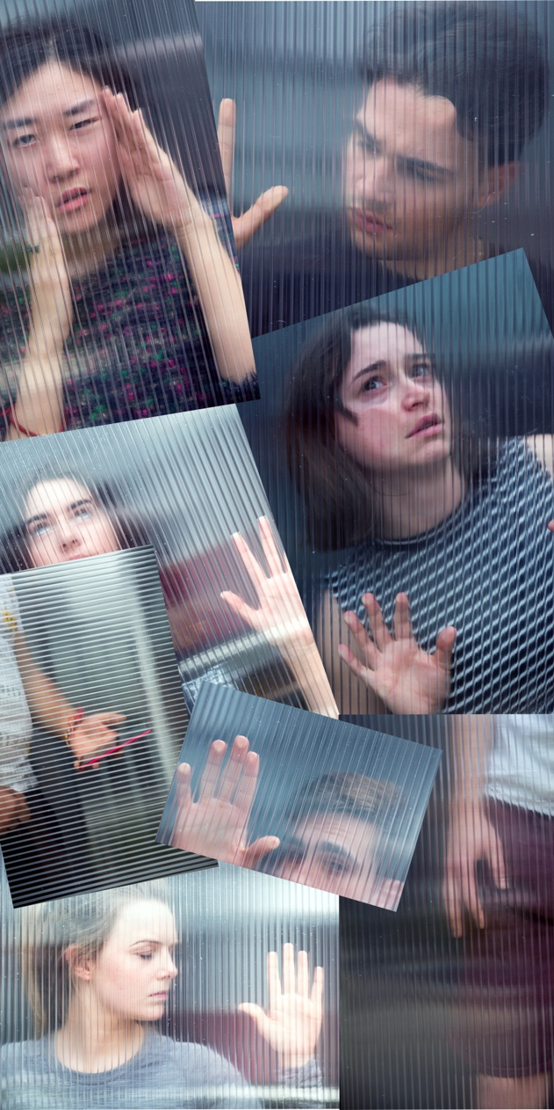
Eight young people navigating high school and beyond, each struggling to hold on – to family, to friends, to a piece of themselves.

https://fragmentstheplay.com

DURATION: Fragments is approximately 85-minutes duration (no interval).

AUDIENCE: Suitable for Years 9-12, with modified activities offered for younger students
(Years 7-8)

Fragments debuted at The Street Theatre, Canberra 23-27 October 2019, programmed for Mental Health Month.

An earlier version of Fragments (monologues only) was performed at the Pioneer Theatre in Castle Hill, NSW, 14-17 November 2018, directed by James Hartley, Upper Crass Theatre Company.

Please note: Fragments contains strong language and themes.

If you or someone you know is experiencing distress and needs help,
please contact Lifeline for 24/7 crisis support on 13 11 14.

TABLE OF CONTENTS

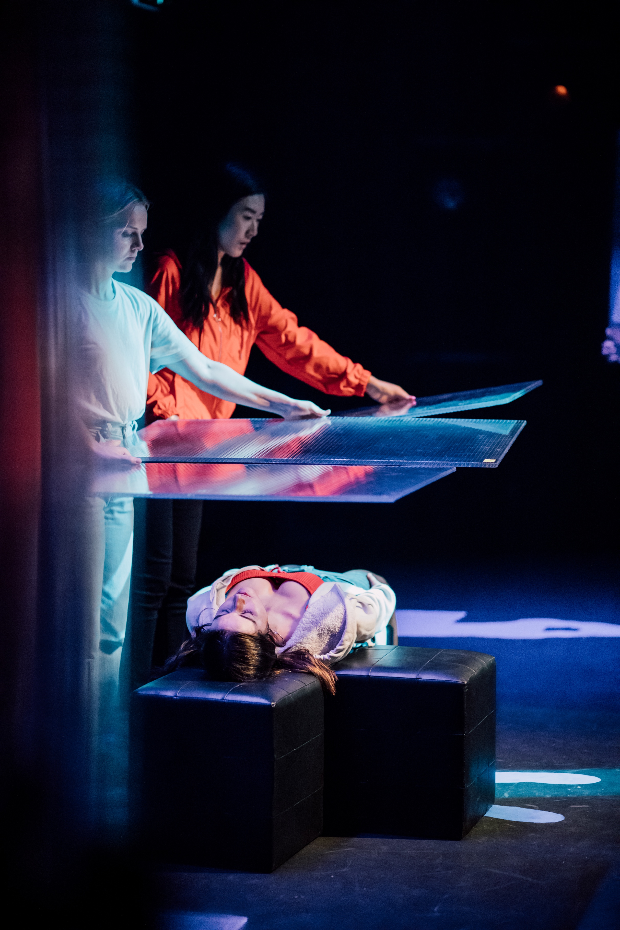

How to Use these Notes 1

About the Playwright 1

What is Fragments About? 2

Themes 2

Provenance of the Work 2

Characters 3

Monologue Synopses 3

Australian Curriculum 4

Interview with the Playwright 6

From the Director 7

About the Production 7
Photo: Creswick Collective, courtesy of
The Street Theatre

Activities (before reading the play) 8

Activities (during/after reading the play) 10

Reviews 17

Mental Health Resources 17

HOW TO USE THESE NOTES

This study guide is intended to be used in the classroom to explore issues and themes featured in Fragments, and to support and extend students’ knowledge and understanding of the work, whether through reading, dissecting, analysing or performing the text. Students are encouraged to explore the many issues and themes highlighted in the work, and the potential of drama/theatre to cast a lens on contemporary issues in society. Fragments has good cross-disciplinary relevance (The Arts, English, HPE, Civics and Citizenship), as outlined under Australian Curriculum on page 4. However, this document is intended as a guide only, and teachers and students are encouraged to introduce their own ideas and experiences in the classroom. The playwright thanks you for choosing her work and welcomes your feedback via email: maura@maurapierlot.com.

ABOUT THE PLAYWRIGHT


Photo: Hilary Wardhaugh Photography

Maura Pierlot is an award-winning author and playwright who hails from New York, but
has called Canberra home for nearly thirty years. Her writing delves into complex issues including memory, identity, self and mental health.

Maura’s debut full-length work, Fragments, enjoyed a sell-out season at The Street Theatre in 2019. in October 201. Maura is the winner of the SOLO Monologue Competition, Hothouse Theatre for her play, Tapping Out, which went on to receive three awards at Short+Sweet Sydney (2017). A former medical news reporter and editor of Australian Medicine, Maura also writes for children and young adults. In 2017 she was named winner of the Children’s Book Council of Australia (CBCA) Aspiring Writers Mentorship Program, and recipient of the Charlotte Waring Barton Award, for her young adult manuscript, Freefalling. Maura’s first picture book, The Trouble in Tune Town, launched in May 2018 at the National Library of Australia, won the 2018 ACT Writing and Publishing Award (Children’s category), along with international accolades. Maura’s essays, poetry and microfiction appear in literary journals and anthologies. Her young adult fiction novel, True North, will be published in 2021.

Maura has a bachelor’s degree, master’s degree and doctorate, each in philosophy, specialising in ethics. When she’s not busy creating, she visits schools and libraries as a guest reader and speaker, serves as a Role Model for Books in Homes, and contributes reviews for the Children’s Book Council of Australia’s online magazine, Reading Time.

WHAT IS FRAGMENTS ABOUT?

Eight young people navigating high school and beyond, each struggling to hold on – to family, to friends, to a piece of themselves.

Perhaps you know them. The bubbly girl who keeps telling you she’s okay. The high achiever who’s suddenly so intense. The young teen obsessed with social media. The boy challenged by communication. Every single day they, and others, are working hard to keep it together. So hard, they don’t see their friends are struggling, too.

Through eight imagined stories, Fragments moves from a place of disconnection to connectedness.

The action of Fragments takes place in the minds and hearts of an ordinary group of eight young people. Although set in Australia, their stories could take place anywhere.

THEMES

Anxiety, depression, neurodivergence, academic success, peer pressure, isolation, self-identity, family dysfunction, bullying, gender dysphoria, eating disorders, heritage and cultural identity, body dysmorphia, relationships, suicide.

PROVENANCE OF THE WORK

Thank you to the following individuals and organisations who supported the development and production of Fragments.
- ACT Government (through artsACT)
- LJ Hooker Canberra City (sponsor of The Street Theatre production)
- The Street Theatre, Canberra
- Australian Cultural Fund (ACF)
- ACF Campaign Donors: Nova Builders, Firedrake Press Editing, NSW Content and Cultural Projects, C&A Pierlot, K Lawton, LJ Hooker Canberra City, S Ingelbrecht
- Ainslie+Gorman Arts Centre, Ralph Indie Program
- Bundanon Trust
- Capital Arts Patrons’ Organisations (CAPO)
- MPS Travel+Tours
- Katharine Susannah Prichard Writers Centre
- Pioneer Theatre, Castle Hill
- Shelly Higgs and James Hartley (directors/dramaturgs)
- Additional dramaturgy: Caroline Stacey and Suzanne Ingelbrecht

CHARACTERS

All of the characters attend the same school except Mila, who is in her gap year.

WILL 16-year-old male FREYA 15-year-old female
VIJAY 14-year-old male REENA 13-year-old female
MILA 18-year-old female NICKY 17-year-old trans female presenting as male
LEXY 17-year-old female MASON 18-year-old male

MONOLOGUE SYNOPSES

Short Circuit

Drawn to rhythm, Will struggles in a world of words, unable to connect to the girl of his dreams, but refusing medication that will make him think like everyone else.

In My Head

On the outside Freya’s a normal teen but on the inside, she’s fighting anxiety every single day, alone and unable to tell anyone that she needs help.

Good for Nothing

Worried he’ll never be tall enough, handsome enough or smart enough, Vijay turns to social media to chat up girls at school, with devastating consequences.

Picture Perfect

Convinced she’s fat, Reena relies on filters to market a better version of herself online, revelling in praise from a growing legion of followers.

Pretty Stupid

Reeling from an abrupt reality check, a young woman sues her school and family for failing to prepare her for life after graduation.

She

Every day she fights to be heard, to dress as she wants, to be who she is ... until one day when she must make a choice, knowing she can never be free as long as he lives.

Roller Coaster

Lexy is determined to internalise her family struggles until a chance meeting opens the floodgates and changes the course of her life.

Now You See Me

Everyone’s so busy looking up to school captain, Mason that they don’t recognise the debilitating depression that is taking over his life.

AUSTRALIAN CURRICULUM

Learning Area | STRAND | CONTENT DESCRIPTION | YEAR 9 | YEAR 10
ENGLISH | LANGUAGE | Language for interaction | ACELA 1551 | ACELA 1564
ENGLISH | LITERATURE | Responding to literature  Examining literature  Creating literature | ACELT1771  ACELT 1634  ACELT 1635  ACELT 1636  ACELT 1637  ACELT 1772  ACELT 1773 | ACELT 1640  ACELT 1641  ACELT 1774  ACELT 1814
ENGLISH | LITERACY | Texts in context  Interacting with others  Interpreting, analysing, evaluating  Creating texts | ACELY 1739  ACELY 1740  ACELY 1811  ACELY 1741  ACELY 1744  ACELY 1746 | ACELY 1749  ACELY 1750  ACELY 1813  ACELY 1751  ACELY 1756
THE ARTS | DRAMA | Improvise with the elements of drama and narrative structure  Manipulate combinations of the elements of drama to develop and convey the physical and psychological aspects of roles and characters  Practise and refine the expressive capacity of voice and movement to communicate ideas  Perform devised and scripted drama making deliberate artistic choices and shaping design elements to unify dramatic meaning for an audience | ACADRM047  ACADRM048  ACADRM049  ACADRM051
THE ARTS | MUSIC | Plan and organise compositions with an understanding of style and convention, including drawing upon Australian music by Aboriginal and Torres Strait Islander artists | ACAMUM102
THE ARTS | MEDIA ARTS | Manipulate media representations to identify and examine social and cultural values and beliefs, including those of Aboriginal and Torres Strait Islander Peoples | ACAMAM074
THE ARTS | VISUAL ARTS | Manipulate materials, techniques, technologies and processes to develop and represent their own artistic intentions | ACAVAM126
THE ARTS | DANCE | Manipulate combinations of the elements of dance and choreographic devices to communicate their choreographic intent | ACADAM021
CIVICS & CITIZENSHIP | KNOWLEDGE & UNDERSTANDING | Citizenship, diversity and identity | ACHCK080
CIVICS & CITIZENSHIP | SKILLS | Analysis, synthesis and interpretation  Problem-solving and decision-making | ACHCS084  ACHCS085  ACHCS086 | ACHCS098  ACHCS099
HEALTH & PE | PERSONAL, SOCIAL & COMMUNITY HEALTH | Communicating and interacting for health and wellbeing | ACPPS094

INTERVIEW
WITH THE PLAYWRIGHT


Photo: Novel Photographic

What is the overarching theme of Fragments?
MP: Rarely presenting as neat packages, mental health issues often involve feelings and behaviours with jagged edged and blurred origins. Fragments embodies the theme that stress at home, at school and in life is challenging young people beyond their usual coping abilities, leaving them disenfranchised and vulnerable.
Why did you write Fragments?
MP: I wrote Fragments to start a conversation, to give a sense of agency to young people while reaching out to their peers, families and the community. It’s only when we speak openly about mental health issues – without fear or judgement – that we can chip away at the stigma that prevents many people from seeking help. This is especially important for young people. So much of adolescent life is spent looking inwards that it’s perhaps not surprising that mental health issues are often internalised and ignored. Swimmers put up their hands when struggling in a rip but there’s no clear, universal signal for people who need help with mental health issues. And sometimes the waters are so turbulent that those who are struggling don’t recognise themselves in each other.
Why a play and not a short story or podcast?
Nothing can replace the thrill, urgency and immediacy of a live performance, though the pandemic has certainly forced a rethink for how to deliver theatrical work. The intensity and sensitivity of the themes and issues highlighted in Fragments seemed best suited to the stage, where the power of human vulnerability can be truly transformative.
What are your aims for Fragments?
MP: In bringing Fragments to the public, I wanted to explore the healing that may come from looking outwards – from our connectedness to others and our realisation that we are not alone. The eight monologues presented here are pieces – fragments – of the countless stories to be told. It is my hope that this work finds its way into schools and communities across Australia and overseas, that it sparks meaningful dialogue, and that we can open our hearts and minds to recognise ourselves in each other.
How does Fragments speak to our times?
MP: Following the play’s sell-out season in Canberra in late 2019, the city was besieged by smoke in a summer like no other. Then, on the heels of the devastating bushfires that heralded 2020, COVID-19 crashed into our collective consciousness. Lockdown, social distancing and hand sanitising became the new normal as people all over the world became disconnected, isolated and fearful. Mental health issues (especially anxiety), already at an all-time high, skyrocketed. Fragments, and its motif of isolation, is now more relevant than ever, not only for young people but for their friends and families, educators, pastoral support teams and health professionals. Mental health touches everyone in communities all over the world. We need to talk about it openly.
FROM THE DIRECTOR

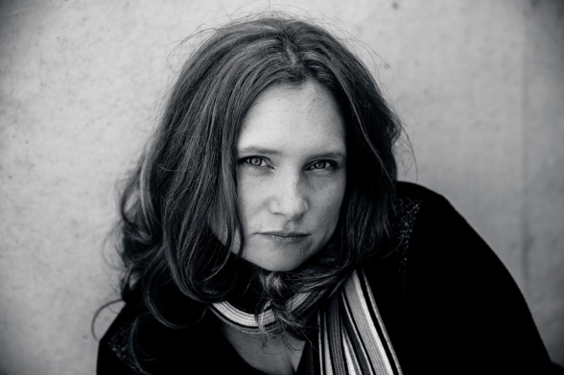
Photo: Shelley Mills Photography

Fragments is an incredibly important work for our times, connecting us to stories of the here and now and giving voice to those who are not always able to speak up. Not only does the work tackle a myriad of issues faced by adolescents, it speaks to these challenges in a way that young people will understand and relate to. How Maura got into the character’s heads so accurately is testament to her talent as a writer.

It was important that the production’s Next Gen actors felt comfortable sharing their own experiences and inevitably brought some parts of themselves to the roles. It was surprising how many personal stories were shared in the rehearsal room and I would encourage anyone approaching this text to do so knowingly; it’s a vehicle not only for the characters’ expression, but often the actors’ own.

Being a series of solo pieces, Fragments offers wide scope and application for this text. The stories stand alone and can be performed separately or even a handful at a time. What is important is how they give voice.

The challenge we faced presenting the pieces together as a whole was to create cohesion to the journey. The play is hopeful, yes, but it’s also careful not to minimise. Ultimately, we found our way by realising this play is one from disconnection through to connection. By the end of Fragments there is a sense that these characters have finally heard and seen each other, but more than that, that the audience may have lowered the walls between themselves for a moment and really seen each other, too. Fragments so desperately seeks “oneness”. And looking around at the audience on closing night, a room full of people talking, sharing their own stories and connecting, a meeting of humanity through mutual experience ... I think it’s fair to say that this text holds that power.

Shelly Higgs

ABOUT THE PRODUCTION

Fragments was produced by The Street in October 2019, programmed as part of Mental Health Month. The production enjoyed a sell-out season and received critical acclaim.
The Street Theatre is Canberra’s leading creative producer and theatre company dedicated to ambitious contemporary live performance, as well as presenting artistically bold performances from other places. The Street’s innovative use of set, sound and lighting created a visceral sense of the mental health themes of the work and the technological world in which the characters live. Abstract worlds contrasted with the interior lives of the characters, separated at times from the audience by shards of glass representing the ‘fragments’ of the title.

The playwright is undertaking further development work at The Street in 2020/21 to create a new piece that gives voice to how young people have been affected by the COVID-19 pandemic.
Note on the following activities:
- All activities have been designed for students in Years 9 and 10 to align with curriculum outcomes.
- Where relevant, adjustments have been suggested for Years 7-8, and Years 11-12. The adjustments are designed as stimulus, rather than complete activities and while not directly linked, are relevant to curriculum outcomes for this age range.
- Drama is the primary focus from The Arts; however, other strands are also relevant and list ideas to get teachers started, rather than comprising a full unit of work.

ACTIVITIES – Before reading the play

BEFORE READING THE PLAY
LEARNING AREA | ACTIVITY – Years 9-10 | ADJUSTMENTS
English | Tap into prior knowledge and social context  - Discuss the title of the play – Fragments. What could it be about? What is a fragment? How can the word be used?  - Read the Interview with the Playwright and From the Director – what do you think the play is about now?  - How is mental illness perceived in Australian society today? In the past? What about the future? What are the main challenges faced by young people today?  - In groups, or as a whole class, begin the creation of a Lotus Diagram ^{Resource 1} Identify up to eight subtopics under the main heading of ‘Youth Mental Health’.  - Read and discuss each monologue synopsis. What is the main issue addressed in each monologue? What do you think it will be about? Where does it fit on the Lotus Diagram?  - Brainstorm and start collecting a list of media and texts that address youth mental health issues and challenges. These may include novels, short stories, blog posts, dramatic performances, movies, songs, artworks. | Years 7-8  Many issues raised in Fragments are also addressed in the Years 7-8 Health curriculum. A modified Lotus Diagram, or a simpler Cluster Diagram ^{Resource 1} may be used.  Years 11-12  Students in Years 11 and 12 may be able to work more independently on the given activities or may wish to explore them further. Creation of a personal reading list could be worthwhile pursuing, and a more detailed text analysis and comparison.
English | Resource 1: Lotus Diagram/Cluster Diagram (https://creately.com/blog/diagrams/types-of-graphic-organizers/#Brainstorming)
The Arts: Drama | Role Play  - Form small groups of 4- 6 students and ask the groups to select an issue/theme relevant to Fragments, e.g. bullying, social media, anxiety, depression, neurodivergence  - Allocate a student to be the person experiencing the issue (change roles often)  - Present possible real-life scenarios and have each student act as themselves in the scenario  - Allow students to make decisions and challenge them. This could be through changing the scenario (e.g. adding a character, changing the setting, changing the response)  - Ask the students to reflect on their actions:  - What could they have done better?  - Why did they react the way they did?  - Is there anyone to blame for their actions?  - Who was the instigator? | Years 7-8  Drama students in Years 7 and 8 may do a modified version of this activity.
Health & PE | Looking after friends  Ask students to discuss what would they do if they believed a friend was experiencing stress?  - How would you approach your friend?  - What would you say to them? | Years 7-8  Discuss the importance of valuing diversity and the strategies for demonstrating empathy and sensitivity
Civics & Citizenship | Influence of media and social media  - Briefly discuss the central themes of Fragments as a whole, and of each monologue.  - Guide students, individually or in groups, to search for media or social media examples of where these themes are addressed.  - Sort examples according to their level of (mis)representation, stereotype, (over) generalisation, assumption. Allow students to determine their own categories but ask them to justify why they place items in these locations. | Years 7-8  Focusing on a selection of the themes from Fragments, discuss different perspectives and the language used around these.

ACTIVITIES – During/after reading the play

LEARNING AREA | FOCUS | ACTIVITY – Years 9-10 | ADJUSTMENTS
English | Initial response | Which monologue/character do you identify most with and why? Write your own short monologue in your voice, or that of a fictitious character, responding to what you have read and how it makes you feel.  Keep a list of the key themes, challenges and issues as they arise. Do they overlap? Are there any common themes?  Are the issues and challenges faced by the characters in Fragments universal? Do/will they transcend time? Discuss. | Years 7-8  Activities listed for Years 9-10 may be modified to meet outcomes for Years 7-8, noting modification of some themes may be necessary.  - Initial response  - Focus on a smaller selection of themes, discussing and exploring those that are immediately relevant to the students’ world.  - Close study  - Focus on language use to meet specific purposes, e.g. character development, influencing opinion  - Significance  - Compare and contrast characters within Fragments  - Informed reaction  - Experiment with language features to create new, short paragraphs/texts
English | Close study | Critique one of the monologues, focusing on plot, pacing and stylistic conventions. Is the character (and their language) credible? What literary techniques does the playwright use? Does the monologue reach a satisfying conclusion?  Consider the language used throughout the play. What does it reveal about the characters? How does it make the reader feel?  Ask students to select a short scene from their lives and try to emulate the playwright’s style in a monologue.  What role do the post-dramatic transitions serve in storytelling? Would the monologues have the same impact if performed alone rather than as part of a unified work? Why do you think the playwright used this technique?  As a class, in groups or individually, students compose an email to the playwright. In this they should identify the impact the play has had on them. Which parts resonated? Which ones didn’t? How did they feel about the themes? The style? How do they feel about an adult writing the voice of today’s youth? Do they see a sequel as viable and, if so, how could this be done? As a novel? A play? A series of short stories? What issues are there still to be covered?
English | Significance | Compare and contrast a Fragments monologue to another text, e.g. Vijay (‘Good for Nothing’) and The Perks of Being a Wallflower (book/film); Lexy (‘Rollercoaster’) and Euphoria (TV show)  Complete a chart, comparing and contrasting: theme, central characters, ending, setting, personal response.  In the ‘Fatal Error (Coding)’ scene, the narrator says:  Coding is power. And choice.  You can write any script you like.  The scene acts as a turning point for the characters, particularly Mason. Discuss the concept of ‘coding’ and how it is relevant to the characters, and to the youth of today. Write a response to this from the point of view of one of the characters, maintaining their voice and attitudes. | Years 11-12  Activities for Years 9-10 may be modified and extended to meet outcomes in:  Essential English - Unit 3  - points of view  - perspectives  - values  - Unit 4  - global, local and community issues  - language choice  English  - Unit 4  - challenge perspectives, values and attitudes  - relationship between voice and perspective  Literature  - Unit 4  - structural and stylistic features of plays  - representation of values and ideas
English | Informed reaction | Write a character backstory or diary blog as the character, using prompts from the script:  - I’ve never been good with words. (Will)  - Fat! Fat! FAT! (Reena)  Design a cover or promotional poster for Fragments and write a 100-word blurb to go with it.  Write a short story, or new monologue about the same event but from a different perspective, e.g. What if Vijay were a female character? What if Nicky lived in a different country, or time period?
English & Drama | Creative Response | Any of these activities are suitable for both English and Drama  - Write a monologue from another character’s perspective.  - Write a monologue from the perspective of the character’s public self vs private self.  - Discuss who the character is addressing (e.g. themselves, a peer, parent, psychologist)?  - Choose a different audience for the character and discuss how the language, tone and energy of the text/performance changes.  - Work in character pairs (e.g. Vijay and Reena, Freya and Will) to write new material from other character’s perspective. | Years 7-8  Similar activities may be undertaken  Years 11-12  Write new material, or the next scene (epilogue), or a prologue, keeping the style consistent
The Arts: Drama  (Developed in consultation with Shelly Higgs.) | Interpretive | Individual: Choose a character and devise a movement piece as a free-flowing and improvisational exercise that charts their emotional journey throughout their monologue. No words. Focus on rhythm and pace, use different levels and space. Does your character move quickly or slowly, and how do they change from beginning to end? What unseen pressures are on them (e.g., Mason)?  Group: Choose a character and improvise a movement piece around (and with) the other characters. Do you go towards people or away from them? How does the presence of someone else effect your own movement? Focus on rhythm and pace, ebb and flow and use of different levels and space. This exercise is all about response so be aware of how you are affected by others and how you affect them. | Years 7-8  Drama students in Years 7 and 8 may do a modified version of some or all of the listed activities. They will explore and experiment with voice, roles and dramatic techniques as guided by the teacher. They may work with modified scripts, or through improvisation.
 | Talk | In groups of 3+ students: Students form a circle with their backs turned to a student, who stands inside the circle as a character from the play. Students start talking judgmentally about the character in the middle of the circle. As the character, try to get the people in the circle to turn around and face you by responding to them, explaining yourself. How successful are you? Do you even want to try? What does this say about your character’s self esteem?  Now switch roles - make sure everyone experiences what it’s like to be the character in the middle of the circle.
 | Walk/Gesture | Walk: Walk as yourself, then walk in the shoes of your chosen character. Adopt mannerisms, facial expressions and interactions in character. How fast does your character walk? What part of their body leads? How visible do they want to be?  Change your pace, posture, presenting part and see how this changes your character (eg, shoulders back and chest forward vs hunched over and small).  Gesture: Come up with a gesture for your character (wringing hands, tapping leg, shrugging etc). Amplify this gesture from “1” (being a normal gesture we wouldn’t notice) to “10”, where the gesture takes over the entire movement of the character. What does this tell you about your character?  Place yourself in different scenarios (e.g. school, home, activities) What changes? What stays the same? What triggers the character in different scenarios?
 | Fear | Identify the main fears for each of the characters or for your character of your choice.  Is fear blocking them from an action or emotion?  What would happen in the absence of fear? (For example, if Reena was interested in, and pursuing, Vijay?)
 | Create | Physically move around the space to create a world that exists in the chosen character’s head. Allow yourself to be as abstract as possible (be open to any movement, ideas, words). This is a great exercise for character development and performance, allowing the actor to be fully present without relying on words.
 | Physical/Somatic | Try overexaggerating the script and words. For example: Freya struggles with anxiety. If you haven’t experienced anxiety before, what do you think it would feel like? How would a person speak when trying to describe anxiety to another?  Try reading/performing In My Head (Freya’s monologue) as though you cannot catch your breath. Note how that affects your emotions and performance. Try the same with others experiencing breathlessness around you. Try reading/performing Now You See Me (Mason’s monologue) as someone not able to move, i.e., being held down or pulled back by others. Or try reading/performing Short Circuit (Will’s monologue) with emphasis on rhythm/tapping.
 | Pressure Test | Put the characters under pressure from peers.  - What would make the characters do something they didn’t want to do?  - What would it take for them to not give in to their peers?
 | Imagery | Explore imagery in one or more monologues. For example: In ‘Picture Perfect’ explore the photocopier, mirror, self-portrait.  - What does the imagery tell you about the characters, their self-image and their view of the world?
 | Produce and Perform | Collaborate as a member of a drama production team to interpret, rehearse and perform Fragments.
The Arts: Dance | Improvisation | Take one element of Fragments – a theme, a character, an emotion – and choreograph a short dance sequence to portray the central message.  Analyse and appraise your selections, including manipulation of elements. | Years 7-8  Experiment with dance elements, select and perform a short sequence to convey a central emotion from Fragments.
The Arts: Visual Arts | Technique & Intention | Students select the monologue which resonates the most. Explore why this is? Is there empathy for the central character? Is there a connection?  Experiment with different techniques and processes to produce a series of works expressing the emotions or central themes of the chosen monologue. Complete a rationale analysing the choices made and their impact on the overall artwork. | Years 7-8  Explore symbols in different artworks, specifically those that reflect issues important to youth. Students design and incorporate their own symbol into an artwork based on a chosen element of Fragments.
The Arts: Music | Compose & arrange | Students select a monologue that resonates with them. Explore the changing and evolving emotion associated with the monologue. Identify suitable styles or genres that could accompany the monologue.  Using technology as a composition tool, or other sources, compose accompanying music to be played in the background of an excerpt of the spoken monologue. | Years 7-8  Select a known piece of music and manipulate some elements to change the style, enhancing the connection with one of the themes in Fragments.
The Arts: Media Arts | Re-imagining | As a group, list the key issues in youth mental health and wellbeing that are raised throughout Fragments. Explore and identify where these are represented in the media. Locate multiple viewpoints if possible.  Select from a range of images, soundbites and artworks, including those produced by the student, and remix these to produce a new version which presents a variety of viewpoints. | Years 7-8  Create a media artwork to represent a key theme in Fragments, using a combination of technical and symbolic elements.
Health & PE | Communicating and interacting for health and wellbeing | After reading the play, revisit the questions asked in the pre-reading activity. Discuss any changes in perspectives and attitudes.  Select one of the characters and create a strategy or an action plan to assist and support this character. The plan may be presented as a flow chart, brochure, fact sheet, role play script or in a form of the student’s choice. | Years 7-8  Revisit discussion from pre-reading activity. Generate a list of actions to support the mental health and wellbeing of others.
Civics & Citizenship |  | Select a challenge experienced by one of the characters in Fragments.  Critically analyse the points raised in the monologue in relation to stereotypes, assumptions, bias and impact.  Further explore the mental health issue through media and other sources. Identify trends and change over time.  Devise and present evidence-based strategies for negotiation and conflict resolution that considers multiple perspectives and, if applicable, the legal system. | Years 7-8  Focusing on one of the monologues, identify different perspectives and what may have informed them. Recognise assumptions that are made and suggest inclusive practices as mediation strategies.

(With the exception of Drama, all activities and curriculum links were developed in consultation with Kellie Nissen, Just Right Words.)

FRAGMENTS REVIEWS

New Territory

http://bit.ly/FragmentsNewTerritory

Artshub

http://bit.ly/FragmentsArtsHubReview

Canberra Critics Circle

https://ccc-canberracriticscircle.blogspot.com/search?q=Fragments

ADDITIONAL RESOURCES (mental health)

Early intervention, support and treatment key to managing mental health conditions in young people.
https://healthyfamilies.beyondblue.org.au/age-13/mental-health-conditions-in-young-people

Increased rates of anxiety and depression reported during COVID-19

https://www.livescience.com/depression-anxiety-increase-covid-19.html

Social isolation and loneliness can be harmful to both mental and physical health.

https://www.aihw.gov.au/reports/australias-welfare/social-isolation-and-loneliness

Wellbeing during times of uncertainty

https://www.goodgrief.org.au/sites/default/files/Season Growth Toolkit Selfcare Times Uncertainty COVID19.pdf

Youth mental health issues on the rise during COVID-19

https://www.theage.com.au/national/victoria/experts-warn-of-deepening-mental-health-crisis-as-youth-bear-brunt-of-covid-19-lockdown-20201113-p56e9d.html

For Fragments press coverage, additional reviews, testimonials, photos, highlights reel
and more, please visit: https://fragmentstheplay.com.

